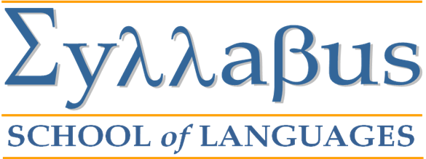
GREEK LANGUAGE COURSE APPLICATION FORM.
SURNAME
NAME
TITLE (Mr, Mrs, Ms, Dr. etc)
HOME OR CONTACT ADDRESS
with Post Code
TELEPHONE NUMBER & FAX
MOBILE PHONE TEL. NUMBER
E-MAIL ADDRESS
DATE OF BIRTH
NATIONALITY
LANGUAGE LEVEL IN GREEK
(beginner, elementary, intermediate, upper intermediate, advanced)
OTHER SPOKEN LANGUAGES
PROFESSION
STUDIES-ACADEMIC BACKGROUND
COURSE DATES
COURSE PROGRAMME SELECTED
(see available choices on-line)

DO YOU REQUIRE ACCOMMODATION?
DO YOU HAVE DISABILITY?
IF YES, PLEASE SPECIFY IF YOU REQUIRE ANY SPECIAL ARRANGEMENTS

PLEASE ALSO ENCLOSE:
- A COPY OF YOUR PASSPORT OR ID CARD.
- A passport size PHOTO.
- A COPY OF THE RECEIPT OF THE BANK TRANSFER OF THE ENROLLMENT FEE AND THE DEPOSIT OF 50% THAT CORRESPONDS TO THE TUITION FEES.

Declaration.

I __________________________________________________ (print name)
hereby declare that all the information given is true and complete and I agree to the Syllabus School of Languages Terms and Conditions as described on the website. I also acknowledge that the School reserves the right to alter any course, subject, admission requirement or fee without prior notice. I understand that the personal information I have provided may be released to government agencies as required by law. I further understand that it may be disclosed to third parties for the purpose of progressing my application.

Date Signature

Please email or post the completed application form to:
Syllabus
School of Languages,
Chrys. Ganiari 13,
Farkaina,
Chios, 82100.
Greece.
info@syllabus.edu.gr

